Part of developing as a diagnostic practitioner is having a clear knowledge base of how learners learn. This knowledge base comes from examining concepts and theory. Human development, cognition, and language are key components when trying to diagnose a learner’s needs. Understanding concepts and theories around these precepts is important.
We’ll begin by examining Bronfenbrenner’s bio-ecological model of human development. Bronfenbrenner’s model, as outlined in the research, stated that outside systems influence children. His model had four systems that he referred to as: microsystem, mesosystem, exosystem, and macrosystem. You can read a description and example of each system below as you move from the system with the most influence (Microsystem) to that with the least influence (Macrosystem).
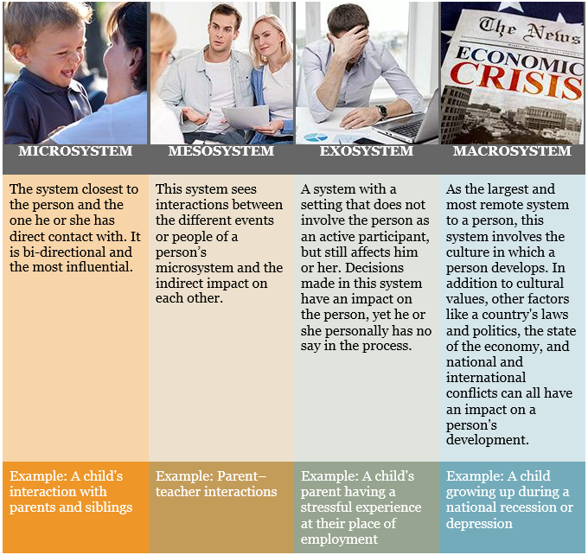
Bronfenbrenner’s model examined the influence and impact on the individual based on each level. As a teacher, how might development influence learning and the learner? Consider the following examples of how development, based on this model, could impact learning.

Case Study 1
Johnny is not close with his family, and he is struggling in school. When asked by his teacher to do something, he eagerly finishes it. However, John does not complete anything that is assigned at home or if it involves his parents. John’s parents are well educated, stable, and considered successful in the community. His parents and teacher have worked positively together to try to resolve his problem, and his parents do attend teacher conferences and communicate with his school. John was given the choice to set goals about completing his work, which he readily agreed to, yet he still does not complete homework.
According to Bronfenbrenner’s model, what development influence is impacting John’s learning?
- Microsystem (YES)
John is not close with his family. According to Bronfenbrenner, the microsystem directly impacts the child. John has a positive relationship with his teacher (completes in-class work), yet is at odds with his family (does not complete his homework or any projects with his parents).
- Mesosystem (NO)
John’s parents and the teacher interact in a positive and effective manner. According to Bronfenbrenner, the mesosystem has to do with the interaction of a child’s microsystems. For John, that would be the interactions between his parents and teacher.
- Exosystem (NO)
John’s environment thus far has been stable. According to Bronfenbrenner, the exosystem refers to decisions that impact the individual without their input. John was asked what goals he wished to set and was included in the process.
- Macrosystem (NO)
John does not appear to have any cultural conflicts within his current school setting. According to Bronfenbrenner, the macrosystem is when a child’s culture conflicts or influences the child directly.

Case Study 2
Maria is a student that speaks limited English. She is extremely shy and does not address any adults unless prompted continually. Maria likes her teacher and seems to do all of her work when it is translated to her native language. Maria’s parents and teacher have a positive relationship, and have met several times to try to think of ways to encourage Maria in her learning. Each meeting has had an interpreter as Maria’s parents speak very little English. Maria has lived in the same neighborhood she was born in and has very close family and community ties. It was suggested that Maria be tested for special education, but Maria's teacher and parents decided to wait since she does score high in all areas when the material is translated.
According to Bronfenbrenner’s model, what development influence is impacting Maria’s learning?
- Microsystem (NO)
Maria is close with her family. According to Bronfenbrenner, the microsystem directly impacts the child. Maria has a positive relationship with her teacher and her family.
- Mesosystem (NO)
Maria’s parents and the teacher interact in a positive and effective manner. According to Bronfenbrenner, the mesosystem has to do with the interaction of a child’s microsystems. For Maria, that would be the interactions between her parents and teacher.
- Exosystem (NO)
Maria’s environment thus far has been stable. According to Bronfenbrenner, the exosystem refers to decisions that impact the individual without their input. Maria has not had any decisions made for her. Though special education was suggested, it was not acted upon.
- Macrosystem (YES)
Maria appears to have cultural conflicts within her current school setting. According to Bronfenbrenner, the macrosystem is when a child’s culture conflicts or influences the child directly. Maria and her family have limited English-speaking skills, and this is impacting her ability to learn and communicate effectively. In addition, Maria’s inability to speak out in class may also be an impact of her cultural conflict.
Teacher Toolbox: Culminating Connections Using a Graphic Organizer
As you begin your teaching career, you will begin developing a strategy “toolbox.” These strategies can be applied as they are meant to enhance the learner experience. One such “tool” is the use of graphic organizers. A graphic organizer is a visual representation of relationships and designations of terms. the following graphic organizer will help you make connections among the theorists you are examining throughout this course. As we cover each theorist, fill in this organizer to use as a reference.
- Comparative Theory Chart https://docs.google.com/document/d/1YWTE4zuuHN8zskPs_YC7uZLSz2qSgDbfPS0J_d87-lw/edit?usp=sharing
Again, as you work through each task that introduces you to a new theory/theorist, complete this chart. This can then be used as a visual reference as you work through specific applications of these concepts. At the end of this course, you will submit this graphic organizer

Resources
- Textbook: Using Educational Psychology in Teaching
https://textbookbutler.vitalsource.com/#/books/9780135246320/cfi/6/4!/4/2/2/2@0:0
- Media: Ecological Systems Theory Urie Bronfenbrenner https://youtu.be/aSfPSLBw-Nc
- Matilda Wormwood http://prezi.com/nxwkgfneqcyq/?utm_campaign=share&utm_medium=copy&rc=ex0share
- File: Parent-Teacher Conference Analysis Template
- Comparative Theory Chart https://docs.google.com/document/d/1YWTE4zuuHN8zskPs_YC7uZLSz2qSgDbfPS0J_d87-lw/edit?usp=sharing

Background Information
Bronfenbrenner’s bio-ecological model of human development stated that outside systems influence children. His model had four systems, which he referred to as microsystem, mesosystem, exosystem, and macrosystem. Bronfenbrenner’s model examined the influence and impact on the individual based on each level.
In this assignment, you will examine a case study student, Matilda Wormwood, to determine how Bronfenbrenner’s theory would apply to Matilda’s challenges. You will apply the concepts of Bronfenbrenner’s theory to address Matilda’s issues.

Instructions
- Read Chapter 2, “Cognitive Development,” in your textbook, Using Educational Psychology in Teaching.
- View the media, Ecological Systems Theory Urie Bronfenbrenner https://youtu.be/aSfPSLBw-Nc
- View the Prezi: Matilda Wromwood, keeping the following thought in mind as you review the three embedded short clips of the movie included on the initial page of the Prezi: Using Bronfenbrenner’s Bioecological Theory, create a map of Matilda Wromwood’s developmental influences; Microsystem, Mesosystem, Exosystem, and Macrosystem. Additionally, using the Parent-Teacher Conference Analysis Form, document recommendations you, as an early childhood educator, would share with Matilda’s parents. http://prezi.com/nxwkgfneqcyq/?utm_campaign=share&utm_medium=copy&rc=ex0share
- Download and complete the Parent-Teacher Conference Analysis Template which you will present to Matilda’s parents at the parent-teacher conference.
  - Provide specific examples and explain how Matilda’s observations/ work correlates to his level of development, as outlined by Bronfenbrenner.
  - Use research and the course materials to support your ideas.
- When you’ve completed your assignment, save a copy for yourself and submit a copy to your instructor using the Assignment by the end of the workshop.

